2024-2025 Action Plan

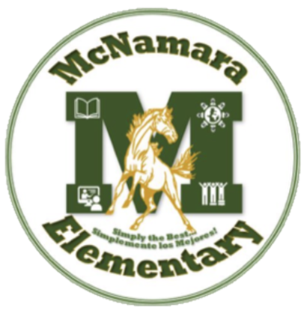

McNamara Elementary

Toufic Elachkar

School Action Plan – Needs Assessment
District philosophy and guiding framework:
Theory of Action
Vision
Core Beliefs

2023-2024 STAAR Data
Our STAAR data from the 2023-2024 school year can be found below.
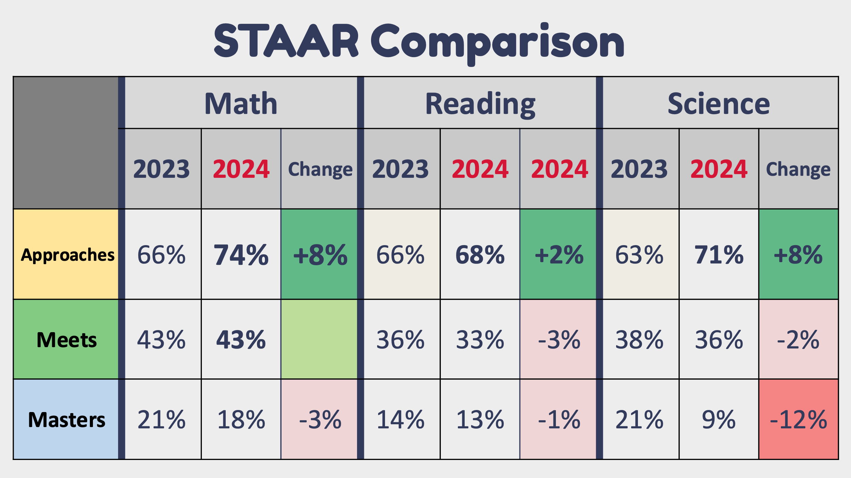
23-24 DIBELS (K-1)
 | Kinder BOY | Kinder MOY | Kinder EOY | 1st grade BOY | 1st grade MOY | 1st grade EOY
Well Below | 48% | 44% | 32% | 44% | 34% | 32%
Below | 13% | 9% | 7% | 13% | 11% | 8%
At Benchmark | 24% | 25% | 22% | 27% | 28% | 28%
Above | 15% | 22% | 39% | 16% | 26% | 31%
23-24 NWEA Map Math (K-5th)
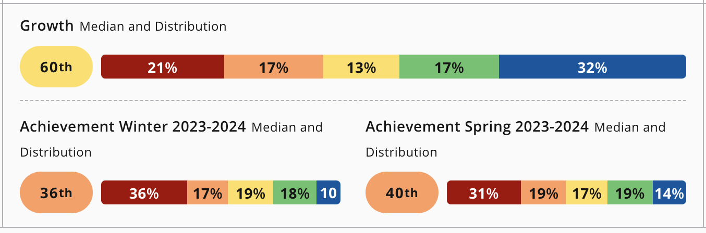

23-24 NWEA Map Reading (2nd-5^{th)}
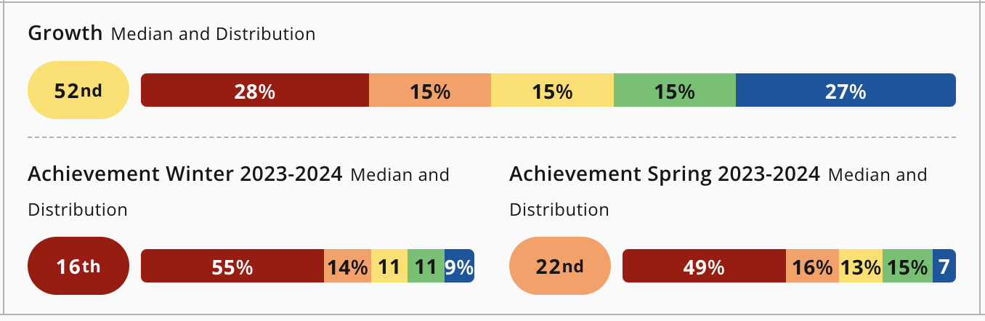
23-24 NWEA Map Science (2nd-5th)
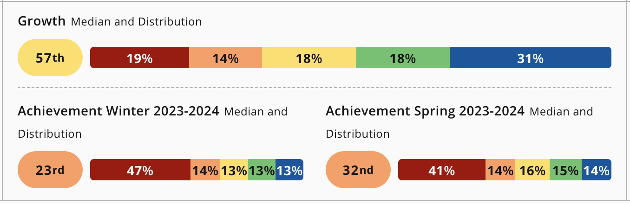

23-24 TELPAS
Grade Level​ | % of students who progressed at least ONE proficiency level​
1st​ | 37%​
2nd​ | 51%​
3rd​ | 30%​
4th​ | 26%​
5th​ | 40%​

23-24 Special Education Campus scorecard (from LEAD)
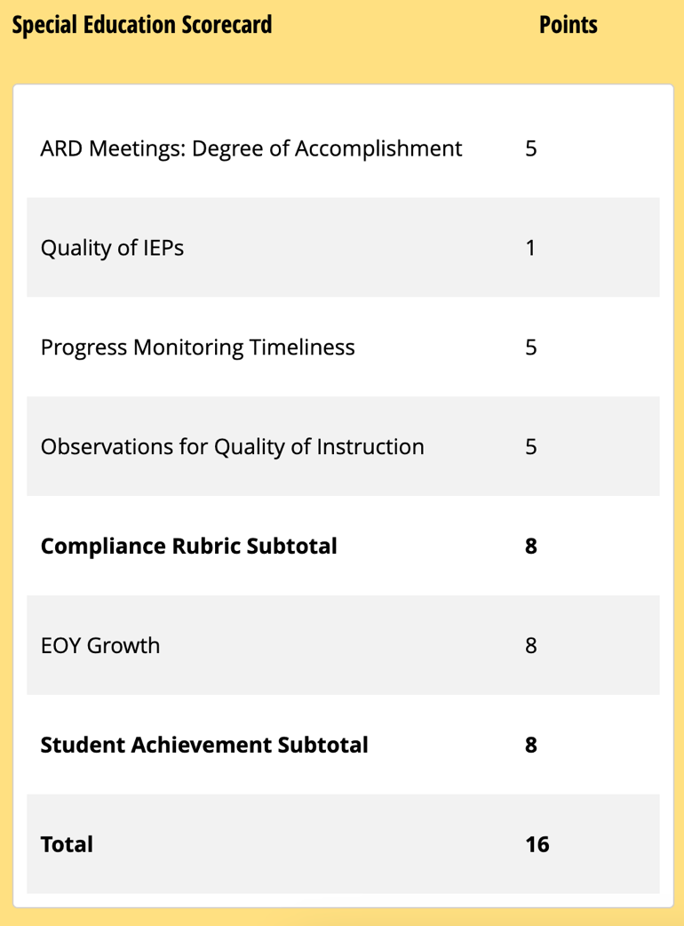
Needs Assessment and Quality of Instruction
Analysis of the data revealed that across most grade levels, the percentage of students at all performance levels was higher for math than in RLA.
A comparison of the STAAR data from last 2 administrations can be found above. Analysis of the data shows an increase at the “Approaches” level for all subjects, and a decrease at the “meets” and “masters” performance levels for some subjects. In addition, the RLA scores showed the least amount of growth. Therefore, based on these data points, we have decided to focus on reading instruction on our campus.
Analysis of K-1st DIBELS/Lectura data for the 23-24 revealed that our students showed continuous growth throughout the school year. Following the End of year (EOY) assessment, it was observed that 32% of kindergarten and 32% of 1st-grade students fell well below the benchmark for reading proficiency. This underscores our commitment to prioritizing good first instruction aimed at ensuring students achieve reading proficiency at grade level in the foundational grades, recognizing the critical importance of building a strong foundation before students' progress to the upper grades.
Analysis of campus NWEA Map assessment data demonstrates that cross all subjects, our campus showed growth in achievement, increasing the percentile distribution by at least 4 percentile points. The growth percentile for each subject was also above 50 for each subject.
After reviewing the TELPAS data from the 2023-2024 school year, we noticed that many of our students did not achieve a full year's growth in their composite scores, and we fell short of our goal of having 49% of students grow by at least one year. This analysis has led us to set a focused goal for the 2024-2025 school year, prioritizing English proficiency for our emergent bilingual students, given the high number of students in this group on our campus. We are committed to supporting their language development to ensure greater progress and academic success.
Last year's special education scorecard showed that we received a score of 1 in the quality of IEPs, highlighting the need for improvement. As a result, we are making it a priority this year to enhance the clarity, specificity, and measurability of all IEPs to better meet our students' needs.

Needs related to improving the quality of instruction
Based on IRT visit data and campus T-TESS and SPOT observation data, there are a few areas that need improvement in the area of quality of instruction:
1. Higher-order questioning: There is a need to enhance the level of higher-order questioning in classrooms across the campus. Teachers primarily rely on lower-level questions that focus on recall or simple comprehension. There's limited incorporation of questions that prompt students to engage in higher-order thinking, such as analysis, evaluation, and synthesis.
2. Using MRS and other classroom data to monitor and adjust in the moment: While teachers collect a variety of data through formative assessments, exit tickets, and observations, there is limited utilization of this data to inform instructional decisions. Teachers include MRS as part of their instruction but may fail to use the data in the moment to adjust and scaffold their instruction.
3. Differentiation: While teachers recognize the importance of differentiation, there is inconsistency in its implementation across classrooms. Some teachers struggle to effectively tailor instruction to meet the diverse needs of all students.
4. Writing instruction: Writing instruction varies across classrooms, with some teachers providing comprehensive writing experiences while others offer limited opportunities for students to develop their writing skills. There's inconsistency in the emphasis placed on writing across subject areas, and some teachers may struggle to incorporate writing effectively into their lessons.
5. English proficiency of EB students: There is a clear need to improve the quality of instruction for our emergent bilingual (EB) students. Teachers must focus on integrating targeted language development strategies, such as structured academic conversations and vocabulary building, to enhance English proficiency. Additionally, providing differentiated instruction and scaffolding will support EB students in achieving grade-level proficiency and making measurable language growth.
System evaluation (philosophy, processes, implementation, capacity)
Philosophy: Our school's philosophy regarding system evaluation emphasizes a commitment to continuous improvement and data-informed decision-making. We believe that regular evaluation of our systems and processes is essential to ensure that we are meeting the needs of all students and providing a high-quality educational experience. Educators who were not modeling this philosophy are not returning to McNamara this year.

Processes: Our system evaluation processes involve a comprehensive review of various aspects of our school's operation, including curriculum and instruction, assessment practices, student support services, professional development, and parent/community engagement. We utilize a variety of data sources, such as student achievement data, observation feedback, and stakeholder input, to assess the effectiveness of our systems and identify areas for improvement. We will improve data meeting discussions where they will be more frequent and a regular part of our improvement cycle.

Implementation: To ensure effective implementation of our system evaluation processes, we have established clear protocols and timelines for data collection, analysis, and action planning. This includes regular meetings of the school leadership team, data review sessions with instructional staff, and collaboration with stakeholders to develop and implement improvement initiatives.

Capacity: Building capacity for system evaluation is a priority for our school. We provide ongoing professional development opportunities for staff to develop skills in data analysis, assessment literacy, and program evaluation. Additionally, we promote a culture of collaboration and shared responsibility, empowering all stakeholders to actively participate in the evaluation process and contribute to school improvement efforts. Our capacity-building efforts also include the establishment of weekly Professional Learning Communities (PLCs) and data prediction meetings with teachers. These serve as dedicated time for collaborative discussion, reflection, and planning among grade-level or subject-area teams. During PLC meetings, teachers analyze student data, share instructional strategies and resources, and develop action plans to address specific areas of need identified through data analysis.

School Action Plan

KEY ACTION ONE | Key Action (Briefly state the specific goal or objective.)  Increase the number of students reading on grade level in English and Spanish in Kinder-3rd grade
 | Indicators of success (Measurable results that describe success.)
- 70% of 2nd-3rd grade students will increase their RIT score on the Reading NWEA Map assessment by 6 points by the MOY administration in January 2025 and at least 8 additional points by the EOY administration in May 2025.
- At least 50% of our students in 2nd-3rd grade will be at or above the 45th percentile nationally in terms of achievement as assessed by the EOY NWEA Map reading administration in May 2025.
- 50% of K-1st grade students will move up one performance level or will maintain at/above performance from the BOY DIBELS/Lectura administration to the MOY administration. That number will increase to 60% of students for the EOY administration in May 2025.
 | Specific actions – school leaders (What specific action steps will the building leaders take to accomplish the
objective?)

  - Leadership team will provide Amplify curriculum materials for English and Spanish instruction and train the teachers on its use by August 12, 2024
  - For select teachers, provide expert professional development (Reading Academy through TEA) on literacy and how to teach reading to students who are behind in proficiency. Teachers will complete the Reading Academy by March 2025.
  - CTC and secondary CTC will train and calibrate teachers on effectively administering the NWEA Map and DIBELS/Lectura assessments by September 15, 2024
  - Appraisers will conduct weekly SPOT observations during the scheduled Reading block for each teacher.
  - Appraisers will conduct weekly SPOT observations during the scheduled Math block for each teacher.
  - Admin will conduct monthly progress monitoring meetings with each grade level to discuss data prediction and next steps
Specific actions – staff (What specific action steps will the staff take to accomplish the objective?)

- During August pre-service weeks, teachers will assemble materials DIBELS/Lectura testing binders, make copies of all materials, and will prepare data trackers for class data and individual student data.
- Teachers will track NWEA Map and DIBELS/Lectura student data consistently throughout the school year and implement targeted, small-group reading interventions for students based on assessment data (RIT scores, DIBELS/Lectura results) to address individual student needs in both English and Spanish.
- Teachers will analyze NWEA MAP and DIBELS/Lectura assessment data after each administration (BOY, MOY, EOY) to adjust teaching strategies and groupings for students who need additional support or enrichment
- Teachers will participate in bi-monthly data prediction meetings in order to plan next steps for instruction.
- Teachers will participate in weekly PLC meetings to share strategies, discuss student progress, and plan cross-grade interventions for reading growth.

 | Key Action One:
Staff Devel. | Who: K-2 teachers (PD led by the leadership team)
 | What: Amplify professional development/training for K-2nd teachers- We will provide targeted professional development sessions for teachers on effectively implementing the Amplify curriculum, with a specific focus on utilizing the 'Skills' portion to equip students with the necessary competencies to read at or above grade level.
 | When: August pre-service PD and ongoing throughout the year
 | Where: McNamara
Budget | Proposed item | Description | Amount
 | Staff development | Done by campus leadership team | $0.00
 | Materials/resources | Amplify curriculum- purchased by the district | $0.00
 | Purchased services | Renaissance/myON online subscription  IXL online subscription | $3,733.00  $13,733.00
 | Other
 | TOTAL |  | $17,466.00
 | Funding sources: GF1

KEY ACTION TWO | Key Action (Briefly state the specific goal or objective.)  Grow staff capacity in providing high-quality instruction
 | Indicators of success (Measurable results that describe success.)
- 65% of teachers will receive a score of 9 points or higher out of 15 total points on the SPOT observations by December 2024. This number will increase to 80% by May 2025.

- 75% of teachers will receive at least 4 points on the “Engage and Deliver” section on SPOT observations by the building leadership team by December 2024. This percentage will increase to 85% by May 2025.
- 65% of teachers will receive a score of “Proficient” or higher on all dimensions in Domain 2 on T-TESS during their one-hour observations by the leadership team by May 2025.
- 15% of teachers will receive a score of “Accomplished” or higher on all dimensions in Domain 2 on T-TESS during their one-hour observations by the leadership team by May 2025.
- In 2024-2025 school year, McNamara will score at least an average of 10 points as determined by an IRT by Round 2 and 11 in IRT by Round 4

- 80% of teachers will attend at least one professional development session on high impact engagement strategies by November 2024. This percentage will increase to 90% by March 2025.
 | Specific actions – school leaders (What specific action steps will the building leaders take to accomplish
the objective?)

- Leadership team will train teachers on the SPOT observation rubric during August pre-service PD and continue to review during monthly PLC.
- Leadership team will train teachers on the HISD-specific student engagement strategies including but not limited to: Think-Pair-Share, White Board, Table Talk, Response Card, Oral-Choral Response, and Quick Response during the August pre-service. This will continue during monthly PD and weekly PLC. The leadership team will model the strategies and allow time for teachers to practice.
- Leadership team will train teachers on campus expectations for high-quality instruction (effective lesson objectives and demonstrations of learning, multiple response strategies, differentiated instruction, the use of technology to improve instruction) during August pre-service and throughout district PD days.
- Appraisers will provide regular on-the-spot coaching and provide feedback daily to each teacher.
- Leadership team will lead and monitor lesson internalization protocol during August pre-service and through weekly PLC meetings with teachers.
Specific actions – staff (What specific action steps will the staff take to accomplish the objective?)

- Teachers will plan and implement effective lessons that include a LO, DOL, and activities that support the objective on a daily basis.
- Teachers will conduct and attend effective weekly PLCs that focus on data and specific intervention strategies and MRS throughout the school year
- Teachers will implement feedback and action steps from SPOT observations daily
- Teachers will use student data to inform instruction and adjust lesson plans, as needed, but particularly after BOY, MOY, and EOY district assessments.
- Teachers will reflect on instructional feedback and improve the delivery of instruction daily.
- Teachers will pre-plan the use of each MRS prior to each lesson to include the preparation of materials needed and planned stopping points during the lesson.

 | Key Action Two:
Staff Devel. | Who: All teachers (PD led by the leadership team)
 | What: Train teachers on campus expectations for high-quality instruction (effective lesson objectives and demonstrations of learning, multiple response strategies, differentiated instruction, the use of technology to improve instruction)
 | When: August pre-service PD and ongoing throughout the year
 | Where: McNamara
Budget | Proposed item | Description | Amount
 | Staff development | Done by campus leadership team | $0.00
 | Materials/resources | Update SMARTboards to new Clever touch screens (4 classrooms), whiteboards, EXPO markers, index cards, sheet protectors | $18,000.00
 | Purchased services
 | TOTAL |  | $18,000.00
 | Funding sources: GF1

KEY ACTION THREE |  | Key Action (Briefly state the specific goal or objective.)  McNamara will improve English proficiency for Emergent Bilingual students.
 |  | Indicators of success (Measurable results that describe success.)
- By June 2025, McNamara will increase the percentage of students achieving at least one level of growth on the TELPAS composite score by 14%, resulting in 49% of students meeting this growth target compared to the 2023-2024 school year data.
- 50% of K-1st grade emergent bilingual students will move up one performance level or will maintain at/above performance from the BOY DIBELS/Lectura administration to the MOY DIBELS/Lectura administration. That number will increase to 60% of students for the EOY administration in May 2025.
- 56% of 2nd -5th grade emergent bilingual students will meet their individual growth target on 2nd -5th NWEA MAP Reading by December 2024 and at least 61% will meet their individual growth target by May 2025.
- By May 2025, 60% of EB teachers will score 7/10 or higher in Domain II (Engage & Deliver and Monitor & Adjust) of the SPOT, as measured by the monthly average SPOT score for second semester.
 |  | Specific actions – school leaders (What specific action steps will the building leaders take to accomplish the
objective?)

  - Leadership team and the language development coordinator (LDC) will provide professional development to teacher on Summit K-12 resources, data reports, and progress monitoring by September 2024.

  - Emergent Bilingual teachers will be coached by the leadership team and the language development coordinator (LDC) on content-based language instruction (CBLI) best practice on how to engage students in listening, speaking, reading, and writing to EB students who are behind in proficiency. Emergent Bilingual teachers will participate in 5 professional development days by March 2025.

  - Appraisers will conduct weekly SPOT observations during the scheduled Reading and ESL block for each teacher with EB students.
  - Language development coordinator (LDC) will provide regular, weekly feedback to teachers of EB students.
Specific actions – staff (What specific action steps will the staff take to accomplish the objective?)

- Teachers and admin will use Summit K-12 to monitor student progress in 2nd-5th grade. Emergent bilingual students will participate in formative assessments through Summit K-12 at least twice a year.

- Teachers will track NWEA Map and DIBELS/Lectura student data consistently throughout the school year and create small groups of students for interventions/enrichment for all EB students.

- Teachers will participate in bi-monthly data prediction meetings in order to plan next steps for instruction, focusing on supports for EB students.
 | Key Action Three:
Staff Devel. | Who: K-5 teachers of Emergent Bilingual students and campus leadership team, LDC
 | What: Teachers will learn content-based language instruction (CBLI) best practice on how to engage students in listening, speaking, reading, and writing to EB students who are behind in proficiency. (PD led by the leadership team)
 | When: September 5, 2024 PLC and ongoing campus or district PD throughout the year
 | Where: McNamara
Budget | Proposed item |  | Description | Amount
 | Staff development |  | Done by campus leadership team | $0.00
 | Materials/resources |  | Summit K-12- purchased by the district | $0.00
 | Purchased services
 | Other
 | TOTAL |  |  | 0.00
 | Funding sources:

KEY ACTION FOUR | Key Action (Briefly state the specific goal or objective.)  The Campus Administrators ensures IEPs are written effectively, staff are provided relevant portions of the IEP, and accommodations/modifications are documented in PowerSchool.
 | Indicators of success (Measurable results that describe success.)
- By the end of the 2024-2025 school year, Campus Administrators will ensure that 100% of IEPs include specific, clear, and measurable goals tailored to each student's unique needs, as verified through random quarterly reviews.
- Throughout the 2024-2025 school year, 100% of staff members receive the relevant portions of the IEP within 3 days of its finalization as demonstrated by campus record keeping.
- 100% of quarterly audits of PowerSchool records will show consistent documentation of accommodations and modifications in PowerSchool by May 2025

 | Specific actions – school leaders (What specific action steps will the building leaders take to accomplish the
objective?)

· Leadership team will ensure special education teachers participate in the Standards-Based IEP Process training through TEA Learns. (Course will be loaded in OneSource)
· Leadership team ensure special education teachers are utilizing Goalbook to create measurable goals.
· Leadership team and Special Education chairperson will work with Special Education Division Unit team to provide teachers training on how to document accommodations and modifications in PowerSchool.
· Principal/Assistant Principals will conduct random checks of accommodations and modifications in PowerSchool and during classroom walkthroughs.
Specific actions – staff (What specific action steps will the staff take to accomplish the objective?)

- The Special Education Division Unit team will collaborate with the SPED Chairperson and ECSE teacher to provide training on how to document accommodations and modifications in PowerSchool by October 2024.
- Special education chairperson and IAT liaison will provide work samples to document the use of accommodations and/or modifications.
- Classroom teachers will collaborate with special education teachers and support staff during IEP meetings throughout the year to develop individualized goals and ensure alignment with student data and needs.

 | Key Action Four:
Staff Devel. | Who: Special education teachers, all teachers, and administrators
 | What: By the end of the first grading period, the Campus Administrators ensures 100% of special education teachers receive training on progress monitoring for IEPs and progress reports (progress track and report card wizard).
 | When: September 3, 2024, PLC and ongoing campus and district trainings.
 | Where: District level and virtual training through the special education department.
Budget | Proposed item | Description | Amount
 | Staff development | Done by campus special education department chair. District trainer TBA | $0.00
 | Materials/resources | IEP data points are tracked weekly and all students with IEPs receive progress reports in alignment with the grading period. | $0.00
 | Purchased services
 | Other
 | TOTAL |  | 0.00
 | Funding sources:

2024-2025 Student Achievement Goals
As a result of the preceding actions, student academic proficiency will increase. Specifically, McNamara Elementary School establishes the following student achievement goals:
Goal 1 – Reading proficiency
Goal 1a: In the 2024-2025 school year, McNamara students will grow 1.4 times the average U.S. growth in reading as measured by the NWEA MAP assessment and using the mean RIT score for each grade, 2nd-3rd.
Goal 1b: 60% of K-1st grade students will move up one performance level or will maintain at/above performance from the BOY DIBELS/Lectura administration by the EOY administration in May 2025.
Goal 1c: STAAR Reading Meets percentage for grades 3 to 5 will increase 7% to reach 40%. STAAR Reading Master percentage will increase 7% to reach 20%.
Goal 2 – Math proficiency
Goal 2a: In the 2024-2025 school year, McNamara students will grow 1.4 times the average U.S. growth in math as measured by the NWEA MAP assessment and using the mean RIT score for each grade, K-3rd.
Goal 2b: STAAR Math Meets percentage for grades 3 to 5 will increase 7% to reach 50%. STAAR Math Master percentage will increase 7% to reach 25%.
Goal 3- Emergent Bilingual
Goal 4: By June 2025, McNamara will see a 14% increase to reach the recommended target metric of 49 of students who hit composite score benchmark as compared to TELPAS SY23-24.
Goal 4- Special Education
Goal 5: By the end of the 2024-2025 school year, IEP score will reach “Proficient” rating in all sections of the SPED performance rubric.

